

VIRUTUAL REALITY INTERNSHIP

An Intern Report

Submitted by

HARI KRISHNAN C(953623104033)



Department of Computer Science and Engineering

RAMCO INSTITUTE OF TECHNOLOGY
(Approved by AICTE, New Delhi & Affiliated to Anna University, Chennai)

Rajapalayam – 626 117
DEC 2025

BONAFIDE CERTIFICATE

Certified that this intern report “VIRTUAL REALITY INTERNSHIP AT SAIRAM INCUBATOR INNOVATION CENTER” is the Bonafide work of “HARI KRISHNAN C (953623104033)” who successfully completed the internship.

SIGNATURE
Dr.K.Vijayalakshmi B.E.,M.E.,Ph.D.

HEAD OF THE DEPARTMENT
Department of Computer Science and Engineering
Ramco Institute of Technology North Venganallur Village Rajapalayam– 626117

SIGNATURE
Ms Rajarajeswari P BE., M.E Faculty In-charge Assistant Professor
Department of Computer Science and Engineering
Ramco Institute of Technology North Venganallur Village Rajapalayam – 626117

TABLE OF CONTENT

S. No. | Section Title | Page No.
1 | Abstract | 4
2 | Introduction | 5
3 | Technology Used | 5
4 | Proposed Work | 6
5 | Performance Evaluation | 10
6 | Results and Discussion | 10
7 | Conclusion | 10
8 | Appendix I (Working Environment) | 11
9 | Appendix II (code,output) | 12
10 | References | 15

Abstract

This report provides a comprehensive overview of the game development training using the Unity game engine. The week was structured to introduce participants to foundational concepts in game programming and design through hands-on learning and project-based tasks. Beginning with basic programming principles and Unity interface navigation, the training covered core topics such as variables, classes, operators, object transformations, and simple physics. Participants then built several mini-games that showcased their understanding of prefab usage, collision detection, animation, UI, sound effects, and scene management. Toward the end of the week, the training shifted focus to Virtual Reality (VR) game development using the XR Toolkit and Oculus Quest headsets. Participants built immersive VR experiences, including a bowling game, a punch bag simulator, and a wave simulation environment. This report documents the learning objectives, technologies used, projects developed, performance evaluations, and future directions, including an upcoming VR-based color sorting game.

INTRODUCTION

Game development is a rapidly evolving multidisciplinary field that sits at the intersection of computer science, creative arts, and psychology. It requires a seamless integration of logic-driven programming, aesthetic design, compelling storytelling, and intuitive user experience (UX) design. During this internship, This include an intensive training period focused on Unity-based Game Development and Virtual Reality (VR) application design. The primary objective of this internship was to move beyond theoretical knowledge and apply industry-standard practices to build functional, interactive software. The training began with the fundamentals of the Unity engine—understanding the component-based architecture and C# scripting—and quickly advanced to complex simulations. A significant portion of the work was dedicated to VR development using the Oculus Quest, pushing the boundaries of traditional input methods by exploring 6-Degrees-of-Freedom (6DOF) controllers and Hand Tracking technology.
The projects undertaken were diverse, ranging from hyper-casual mobile mechanics to immersive VR simulations. This ensured a holistic development curve, covering 2D/3D physics, procedural generation, artificial intelligence for enemy behaviors, and shader programming for visual effects.

TECHNOLOGY USED

To achieve the desired fidelity and functionality, a robust stack of tools and technologies was employed:
- Unity Game Engine (2022.x LTS): Selected for its versatility and powerful cross-platform capabilities. It served as the central hub for scene composition, physics simulation, and build deployment.
- C# Programming Language: The core logic backbone. C# was used for everything from simple movement scripts to complex state machines managing game flow and enemy AI.
- Oculus SDK & Meta Quest 2: The hardware and software interface used for VR development. The SDK provided access to controller data, headset tracking, and guardian system boundaries.
- Unity XR Interaction Toolkit: A high-level component system that streamlined the creation of VR interactions, such as grabbing objects, teleporting, and UI interaction, without needing to write low-level hardware drivers.
- Shader Graph: A node-based visual shader editor used to create custom visual effects (VFX), specifically for the liquid simulations in the color sorting game, allowing for performant yet high-quality visuals.
- Scriptable Objects: A data container system in Unity used to store large amounts of shared data independent of class instances. This was crucial for the modular weapon system, allowing easy tweaking of game balance values.
- Visual Studio Code: The primary Integrated Development Environment (IDE) used for writing, refactoring, and debugging C# code.
- Unity Profiler: Used extensively during the optimization phase to identify performance bottlenecks, specifically looking at CPU usage and memory allocation.

PROPOSED WORK

The internship work was divided into distinct projects, each targeting specific skills and engineering concepts.

3.1 Endless Bicycle Runner Game
Objective: To create a 3D endless runner that relies on procedural generation rather than manual level design.
- Procedural Generation: The core technical challenge was creating the illusion of an infinite road. This was achieved by instantiating "track segments" ahead of the player and destroying segments that passed behind. This "Object Pooling" technique was vital to prevent memory leaks and frame drops.
- Player Mechanics: The bicycle controller used physics-based movement (Rigidbody) rather than simple transform translation to give the movement weight and momentum. Input handling included swipe or key-based lane changing, jumping, and sliding.
- Dynamic Obstacles: Obstacles were spawned randomly on the generated tracks. Collision detection logic was implemented to trigger "Game Over" states or reduce health upon impact.

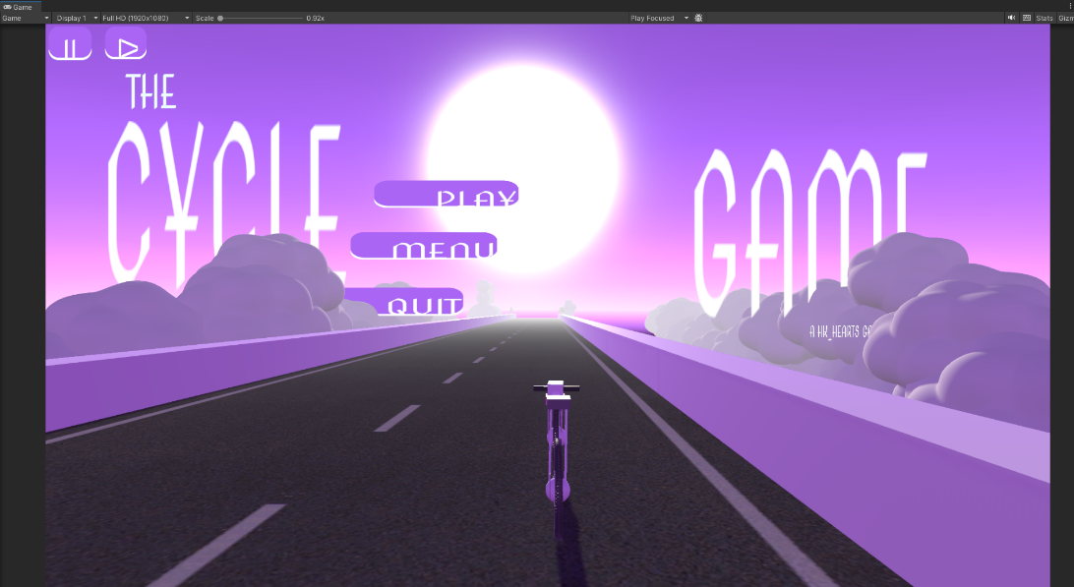
Fig1 : Cycle Game Menu
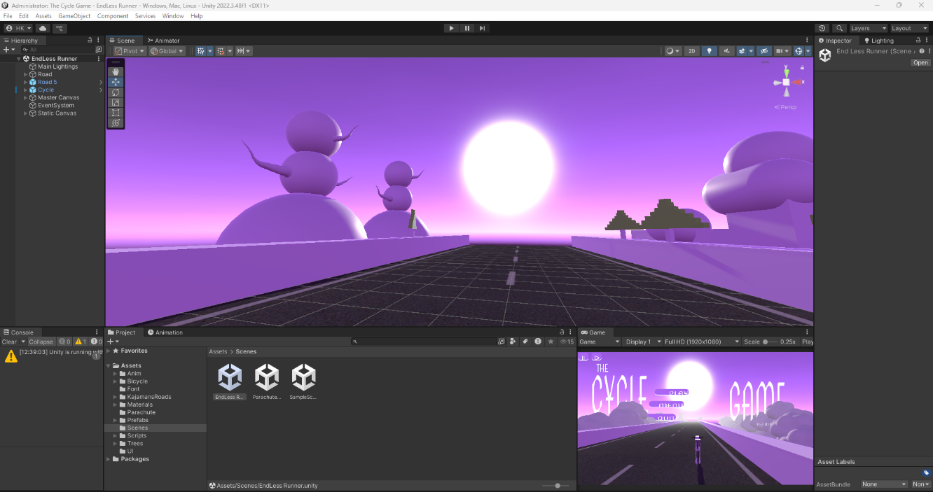
Fig2 : Cycle game

3.2 Shooting Arcade Game
Objective: To build a wave-based shooter that utilizes modular code architecture.
- Modular Weapon System: Instead of hard-coding gun stats, Scriptable Objects were used. This meant creating a new gun (e.g., a Sniper Rifle) only required creating a new data asset and adjusting sliders for "Fire Rate," "Range," and "Damage," making the system highly scalable.
- Enemy AI: The enemies utilized a Finite State Machine (FSM). States included Idle, Chase, and Attack. The AI used vector math to calculate the distance and direction to the player, rotating and moving towards them when in range.
- Game Loop: A "Game Manager" script handled the flow of the game, tracking the wave number, spawning enemies at increasing rates, and managing the player's score and health UI.

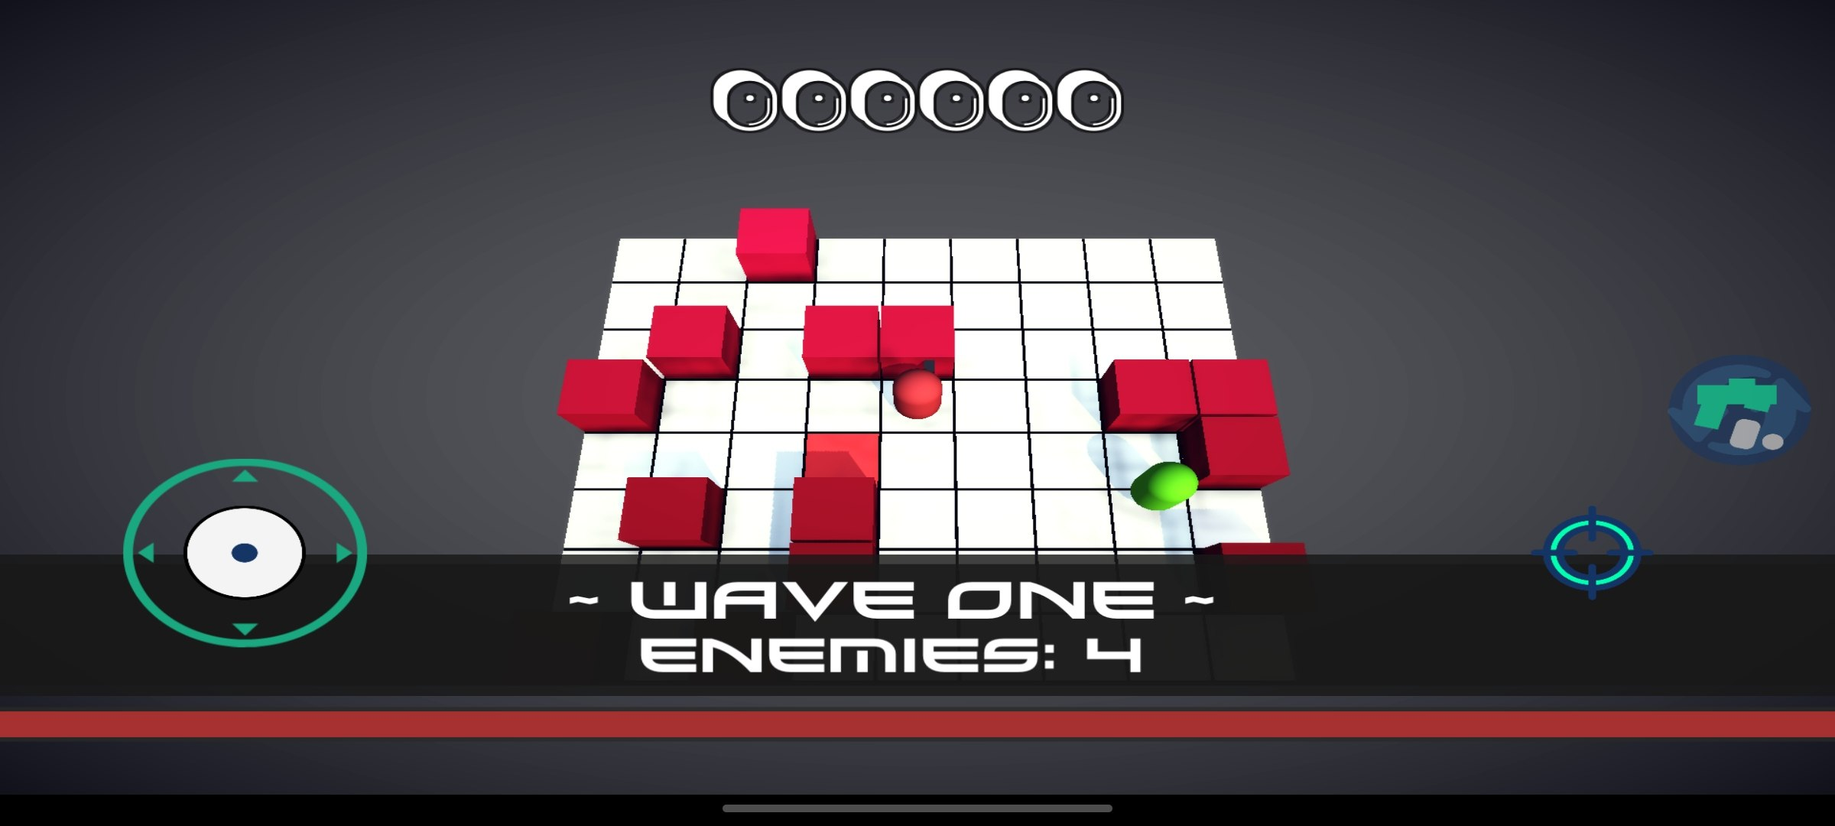
Fig3: Shooting Arcade Game

3.3 VR Basketball Game (Hand Tracking)
Objective: To explore "Controller-less" VR immersion using the Oculus Hand Tracking API.
- Hand Tracking Implementation: The project moved away from standard controllers. The Oculus SDK was configured to recognize the user's real hands, mapping virtual skeletal meshes to the user's fingers in real-time.
- Grabbing Logic: Custom logic was written to detect "pinch" or "grasp" gestures. When the user's virtual hand overlapped with the ball and a grab gesture was detected, the ball was parented to the hand.
- Physics & Trajectory: Releasing the ball required calculating the velocity of the hand at the exact moment of release and applying that vector as an impulse force to the ball's Rigidbody. This required precise tuning to ensure the throw felt natural and not "floaty."

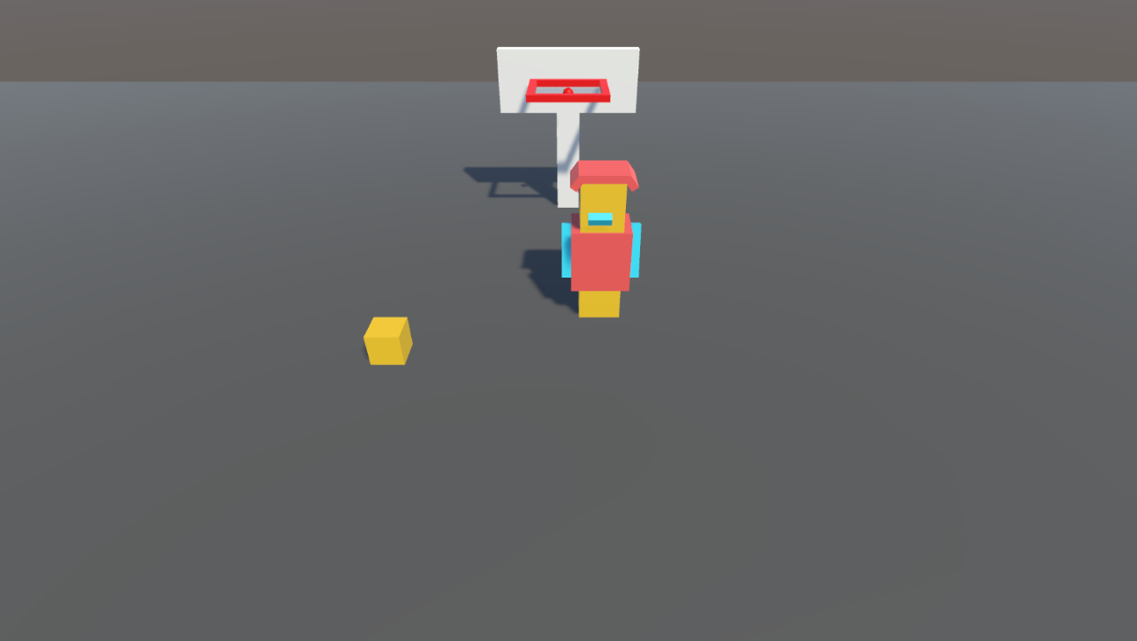
Fig4: BasketBall Game

3.4 Controller-Based VR Interaction
Objective: To master standard VR inputs (Oculus Touch Controllers) for accessibility and precision.
- Locomotion: Implemented different movement types to test user comfort, including "Teleportation" (instant movement to reduce motion sickness) and "Continuous Move" (using the thumbstick like a gamepad).
- Haptic Feedback: Added haptic impulses (vibrations) to the controllers when the player interacted with objects, adding a layer of sensory feedback that improved immersion.
- Interactions: Designed levers, buttons, and doors that could be physically manipulated using the grip buttons on the controllers.

3.5 VR Color Sorting Game
Objective: To combine physics interaction with advanced visual rendering.
- Liquid Shader: A custom shader was created using Shader Graph. This shader mathematically calculated the "fill level" and surface angle of the liquid inside a bottle based on the bottle's rotation. This allowed the liquid to always stay parallel to the ground, simulating real fluid dynamics.
- Game Logic: The core loop involved checking if a ball or liquid poured into a container matched the container's designated color tag. Correct matches triggered positive audio-visual feedback, while incorrect matches triggered error sounds.

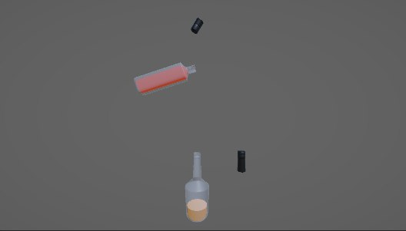
Fig5: Color Sorting

  - Introduction to VR

Transitioning to VR, students configured Unity projects to support Oculus Quest. Key learnings included setting up VR camera rigs, using XR Interaction Toolkit, grabbing and throwing objects, and configuring VR physics.
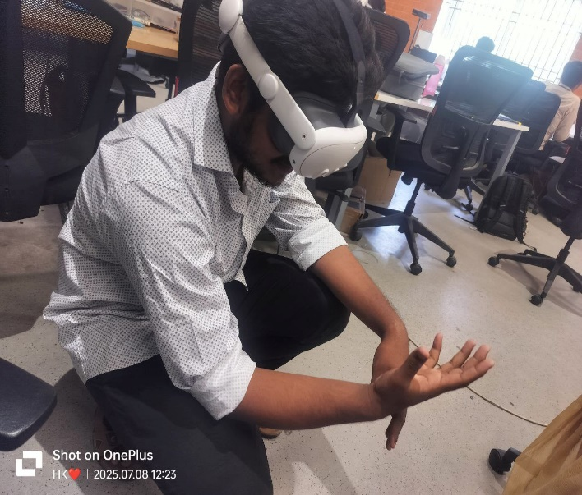

Fig6: Exploring VR

PERFORMANCE EVALUATION
Ensuring smooth performance, especially in VR, was critical to preventing motion sickness and ensuring a good user experience.
- Frame Rate Stability: All VR projects were profiled to ensure they maintained a steady 72 FPS (Frames Per Second) on the Oculus Quest. Drops in FPS were addressed by simplifying geometry and reducing draw calls.
- Memory Management: The "Garbage Collector" in C# can cause stuttering. To mitigate this, Object Pooling was used in the Shooting and Runner games. Instead of creating/destroying bullets and obstacles constantly, they were deactivated and reused.
- VR Latency: Input latency was monitored using the Oculus Performance HUD. The physics time-step was adjusted to sync with the refresh rate of the headset to ensure hand movements felt 1:1 with reality.
- Lighting Optimization: Real-time lighting is expensive. "Baked Global Illumination" (Lightmaps) was used for static environments to reduce the rendering load on the GPU.

RESULTS AND DISCUSSION

The internship resulted in the successful deployment of five distinct prototypes, each demonstrating proficiency in different areas of development:
- Programming Proficiency: There was a marked improvement in C# skills, moving from basic syntax to advanced topics like Delegates, Events, and Coroutines.
- VR Design Principles: The transition from 2D screens to 3D VR space highlighted the importance of scale and user comfort. It was learned that UI in VR cannot be static; it must be "World Space" based or follow the user's gaze.
- Problem Solving: Debugging complex interactions, such as a ball clipping through a wall in VR or an infinite loop in a script, honed analytical thinking and troubleshooting skills.
- Creative Implementation: The Color Sorting game demonstrated that technical shaders can be used to solve gameplay design problems, creating visuals that are both pretty and functional.

CONCLUSION

This internship served as a comprehensive bridge between academic theory and professional application. Trained the ability to take a concept from the ideation phase, through the technical hurdles of implementation, to a polished final build. The work covered the full spectrum of development: Systems Engineering (Game Managers, Save Systems), gameplay programming (movement, combat), and Technical Art (Shaders, Lighting).

Operating System:

Appendix I:

Working Environment

Windows 11 home, MAC mini pc

Game Engine and Platform:
Unity 2021.3+ (LTS version recommended)

Unity was used as the core development environment to create 2D, 3D, and VR games. It provides a complete physics engine, UI system, animation tools, and XR support for VR interactions.

Programming Languages:
C# – Used for writing Unity scripts including player movement, enemy behavior, collision logic, UI management, and VR interaction.

Unity Scripts and Components:
- CycleMovement.cs – Manages the bicycle’s physics, forward acceleration, steering, and lane-switching logic.
- CoinSpawnner.cs – Handles the procedural generation and instantiation of collectible coins along the path.
- SpawnManager.cs – Controls the endless generation of road segments, obstacles, and environment elements.
- TrriggeringScript.cs – Detects collisions with obstacles or collectibles to trigger game-over states or score updates.
- Rigidbody & Box Collider – Enables physics interactions for the cycle and collision detection for triggers.
- UI Canvas System – Displays the running score, distance traveled, and the game-over menu.

VR Tools:
- XR Toolkit – Used to create VR interactions like grabbing, throwing, and button presses
- XR Ray Interactor – For UI interaction in VR
- XR Grab Interactable – For pick-and-place functionality in color sorting and bowling games

Visualization & Debug Tools:
- Unity Scene View – Real-time layout and manipulation
- Game View – Preview actual gameplay
- Console – Debug output and error tracking

Styling and Frameworks:
- Unity UI Toolkit and UGUI – Used for game menus, scoreboards, and HUDs
- Post Processing Stack – Optional visual enhancements (bloom, motion blur, color grading)
- This environment enabled seamless development and testing of all game types, ranging from basic 2D to immersive VR experiences.

Appendix II:

Sample Code

CoinSpawner.cs
private Rigidbody rb; void Start()
{
rb = GetComponent<Rigidbody>();
}
void FixedUpdate()
{
// Always move forward at a constant speed Vector3 velocity = rb.linearVelocity; velocity.z = forwardSpeed; rb.linearVelocity = velocity;
// Get horizontal input
float horizontal = Input.GetAxis("Horizontal");
// If horizontal input is given, move left/right if (Mathf.Abs(horizontal) > 0.01f)
{
rb.AddForce(Vector3.right * horizontal * sideSpeed, ForceMode.Acceleration);
}

// Clamp X position safely Vector3 pos = rb.position;
if (pos.x > rightLimit || pos.x < leftLimit)
{
// Clamp X and reset lateral velocity
pos.x = Mathf.Clamp(pos.x, leftLimit, rightLimit); rb.MovePosition(new Vector3(pos.x, pos.y, pos.z));

Vector3 clampedVelocity = rb.linearVelocity; clampedVelocity.x = 0f;
rb.linearVelocity = clampedVelocity;
}
}
-
CycleMovement.cs

using UnityEngine;
using UnityEngine.UI;

public class CycleMovement : MonoBehaviour
{
public GameObject FrontPiece;
public Button StartButton;
public float moveSpeed = 10f;
public float sideSpeed = 5f;
public float maxSidePosition = 3f;
public float maxWheelAngle = 30f;

float horizontalInput;
bool buttonPressed = false;

void Start()
{
StartButton.onClick.AddListener(isButtonPressed);
}

void isButtonPressed()
{
buttonPressed = true;
}

void Update()
{

if(buttonPressed == true) // Pressing syntax maranthuruchu OnClisk() is event aam
{
TheGame();
}

}

void TheGame()
{
horizontalInput = Input.GetAxis("Horizontal");
Vector3 movement = new Vector3(0, 0, moveSpeed);

if (horizontalInput != 0)
{
float newXPos = transform.position.x + (horizontalInput * sideSpeed * Time.deltaTime);
newXPos = Mathf.Clamp(newXPos, -maxSidePosition, maxSidePosition);

transform.position = new Vector3(newXPos, transform.position.y, transform.position.z + moveSpeed * Time.deltaTime);

float wheelAngle = maxWheelAngle * horizontalInput;
FrontPiece.transform.localRotation = Quaternion.Euler(-44.257f, 90, wheelAngle);
}
else
{
transform.position += movement * Time.deltaTime;
FrontPiece.transform.localRotation = Quaternion.Euler(-44.257f, 90, 0.631f);
}
}
}

SpawnManager.cs

using System.Collections;
using System.Collections.Generic;
using UnityEngine;

public class SpawnManager : MonoBehaviour
{
[Header("Road Props")]
public GameObject[] roadPrefabs;
public float spawnLen = 10f;

// Road Spawn Manager
void OnTriggerEnter(Collider other)
{
int randomRoadIndex = Random.Range(0, roadPrefabs.Length);
if (other.CompareTag("SpawnTrigger"))
{
Instantiate(roadPrefabs[randomRoadIndex], new Vector3(0, 0, other.transform.parent.position.z + spawnLen), Quaternion.identity);

//other.gameObject.SetActive(false);
}
else if (other.CompareTag("DeleteTrigger"))
{
Destroy(other.transform.parent.gameObject);
}
}

}

REFERENCES
- Unity Documentation: https://docs.unity.com
- Unity Learn: https://learn.unity.com
- C# Programming Guide: https://docs.microsoft.com/en-us/dotnet/csharp
- XR Toolkit Docs: https://docs.unity3d.com/Packages/com.unity.xr.interaction.toolkit
- Unity Asset Store: https://assetstore.unity.com
- Unity Forums & StackOverflow.

